Assignment 15

Name: Jeevan Sai Badana

Mail: [jeevansai100@gmail.com](mailto:jeevansai100@gmail.com)

Topic: view tables in spark

Date: 11-02-2024

View tables in spark

First we import spark and sparksessions

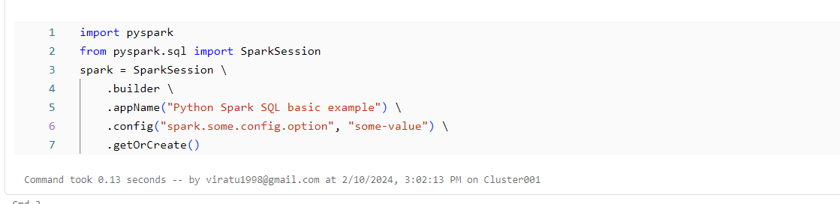

Now we read some csv file using spark.read.csv

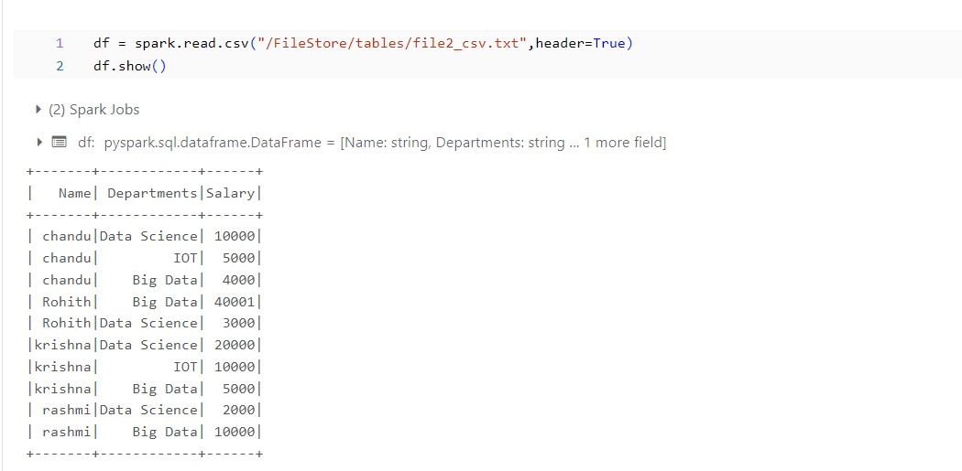

Now we print Schema

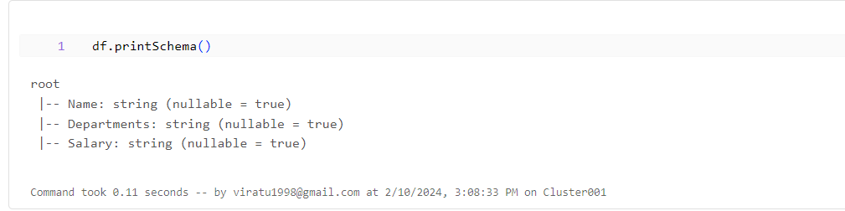

Now we retrieve specific column

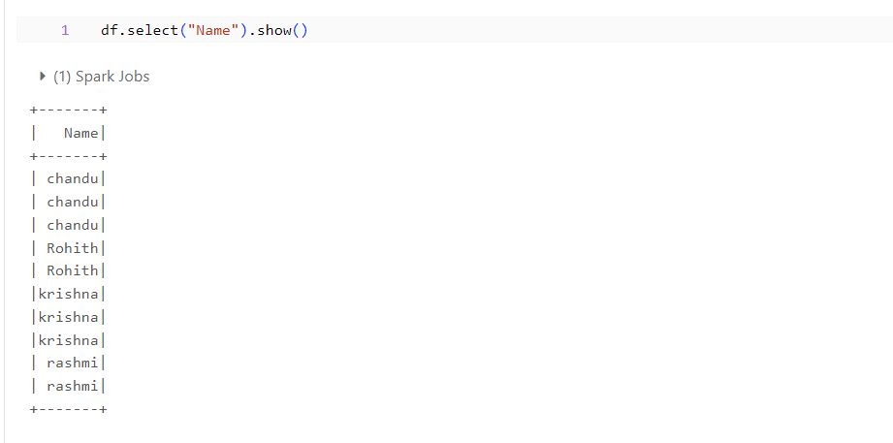

Now we create view table

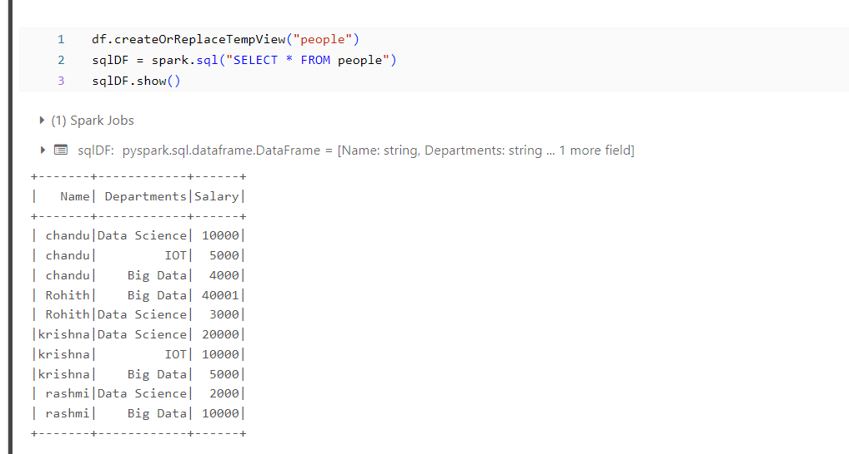

**Running notes:**

